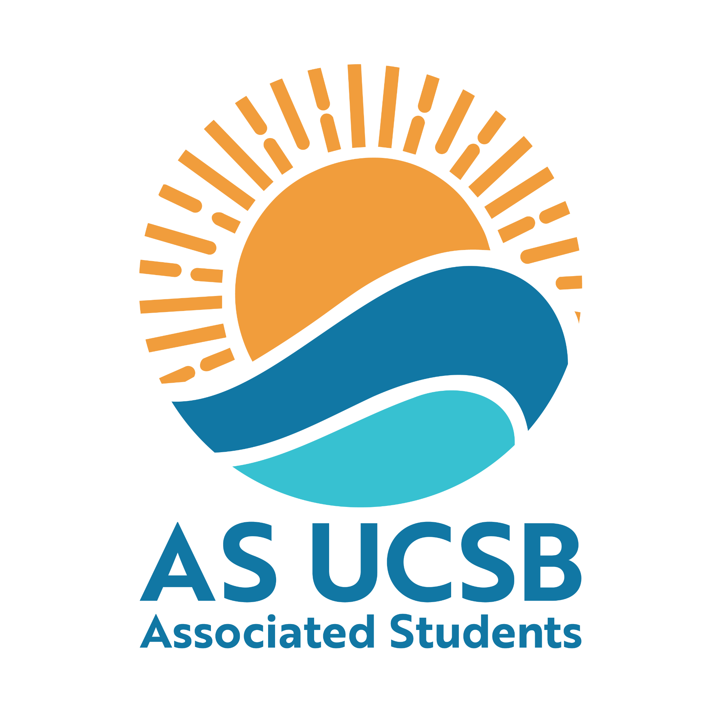

A.S. Committee on Committees Outreach & Recruitment Transition Report

2026

My contact: Mira Ikladious mikladious@ucsb.edu

Purpose of the Position
The Outreach and Recruitment position hosts outreach events and helps find new and dynamic ways to get the student body engaged with student government. Responsibilities include:
  - Making Social Media posts
      - Create infographics for our BCU and other AS entities to advertise recruitment and events
      - Keep in contact with other BCUs on social media, if you support & repost their material, they are much more likely to support yours
      - Support other AS entities through social media if needed/asked to
      - Keep all posts in the Social media folder for fliers and graphics
!

  - Tabling
    - You need to table at least one of your own, independent events per quarter
    - This can be outside arbor or around pardall - anywhere with a lot of foot traffic to promote AS to the student body
    - ^ in addition to this, you should help your COC members table their events as one person is often not enough

  - Honoraria
    - Fill out your Honoraria form every quarter to receive your stipend (300$/quarter)

  - Tracking appointments and resignations
    - This is primarily the duty of the Internal Liaison, but you will be ensuring the form submissions for appointments and resignations are updated to the Appointments Tracker and a summary is sent to both the President’s office and the Senate, weekly.
    - I believe all members will be responsible with helping get this system up and running

Legal Code Duties
Duties and Responsibilities of the Outreach and Recruitment Director and Coordinators:
1) Be responsible for planning and organizing at least one (1) major recruitment fair per quarter. This recruitment fair shall be considered an A.S.-wide event.
2) Collaborates with the External Chair to coordinate Associated Students Week of Welcome events and tabling.
3) Table for a minimum of five (5) hour per quarter in a public place. These hours must be spent actively recruiting students to A.S. entities and Administrative Advisory Committees or Academic Senate Committees.
4) Publicize Associated Students and Committee on Committees through social media.
5) Develop new and innovative ideas for targeted recruitment.
6) Hold a minimum of two (2) office hours per week.
7) Attend all meetings of the Committee on Committees.
8) Coordinate tabling for events at UCSB and in Isla Vista including but not limited to Week of Welcome, Pardall Carnival, Chilla Vista, OSL Organization Fairs and Spring Insight.
9) Publicize the AS Newsletter and AS Brochure developed by the Internal Liaisons.
1 0) Each Coordinator shall be responsible for coordinating at least one (1) outreach or recruitment event per quarter that targets their demographic.
11) Fulfill other duties and responsibilities as assigned by the Chair

Email
- as-outreachrecruitment.coc@ucsb.edu (password: OR202324_ghi)
  - Change your name, profile photo, and email signature
  - This is the account you use to log into slack
- as-coc@ucsb.edu (password: cocmainemail)
  - We don’t use this, but it would be good to check occasionally

Event Ideas / What I Did in the Role

Unfinished projects?
- Projects you didn’t get to finish and hope to be picked back up next year (include the contacts, documents, and background necessary to successfully carry it on)

Important Resources
- The AS Canvas is a great place to have new members trained (you’ll also have some mandatory trainings here)

Important Contacts
- Technically CoC’s AS advisor is Holly Dunn (hollym@as.ucsb.edu)
  - I’ve sent emails into the void to her honestly
  - You can try to establish contact but I have found it more efficient to just slack questions to different AS Admin
- SLACK!!!! ESSENTIAL!!
  - For AS policy or random very specific AS questions → Sean Lieberman is the expert for all things AS. He’s very busy, so only bother him if important
  - For general AS advising (you need to assign a Gateway cart, etc) →Kris Ehrman is awesome. He’s COSWB’s advisor (which I was part of) so I deferred to him for many questions because I had worked with him before.
  - For any financial questions → AS Finance Committee Chairs, Aryan Shukla, or Bryan Hernandez Feria
  - For any CoC website questions → Alex is great Alexander Herbaugh
    - (Slack is best for all of the above, but I linked their emails too)
  - For any tech needs: AS Help Desk
- For student contacts on Senate or Exec:
  - Evan Sussman the GOAT
    - He’s no longer in senate, but will be at UCSB next year and is a good contact for AS (especially
- We had great collaborations with the AS Careers Center as well, I would encourage you to do more projects with them. Here is who I worked with:
  - Alaina Hogeboom
  - LaTia Willis

